
TAMPINES JUNIOR COLLEGE

Preliminary Examinations 2010

CHEMISTRY (Higher 1) 8872/1

PAPER 1 Multiple Choice

Friday 17 September 2010 50 minutes

Additional materials: Multiple Choice Answer Sheet
Data Booklet

INSTRUCTIONS TO CANDIDATES
Write in soft pencil.
Write your name and Civics Group on the Answer Sheet in the spaces provided.

There are thirty questions in this paper. Answer all questions. For each question, there are four possible answers, A, B, C and D.
Choose the one you consider correct and record your choice in soft pencil on the separate Answer Sheet.

Each correct answer will score one mark. A mark will not be deducted for a wrong answer.
Any rough working should be done in this booklet.

This document consists of 15 printed pages.
[Turn over
Section A
For each question there are four possible answers, A, B, C and D. Choose the one you consider to be correct.

1. 10 cm³ of a hydrocarbon C_{x}H_{y} was exploded with an excess of oxygen. There was a contraction of 30 cm³. When the product was treated with a solution of potassium hydroxide, there was a further contraction of 40 cm³. What is the molecular formula of the hydrocarbon?
[All gas volumes are measured at r.t.p.]

A C₄H₈
B C₄H₁₀
C C₃H₆
D C₃H₈

2. Consider the following half-equations.
MnO₄⁻ + 8H⁺ + 5e⁻ → Mn²⁺ + 4H₂O
Fe²⁺ → Fe³⁺ + e⁻
What volume of 0.01 moldm⁻³ KMnO₄ is required to oxidize 15 cm³ of an acidified aqueous solution of 0.1 mol dm⁻³ Fe²⁺ ions.
A 15 cm³
B 30 cm³
C 45 cm³
D 150 cm³

3. Which of the following statements about the reaction below is correct?
IO₃⁻ (aq) + 2I⁻ (aq) + 6H⁺(aq) + 3Cl⁻(aq) 3ICl(aq) + 3H₂O(l)

A The oxidation number of chlorine changes from -1 to 0.
B The oxidation number of chlorine changes from -1 to +1.
C The oxidation number of iodine in IO₃⁻ changes from +5 to -3.
D The oxidation number of iodine in IO₃⁻ changes from +5 to +1.
4. The table below give the enthalpy change of combustion of enthyne (C₂H₂), hydrogen (H₂) and ethane (C₂H₆).
Substance | ΔH_{c} / kJmol⁻¹
C₂H₂ | −1300
H₂ | −285
C₂H₆ | −1560

What is the enthalpy change of the following reaction?
C₂H₂(g) + 2H₂(g) → C₂H₆(g)
A +310 kJmol⁻¹
B +155 kJmol⁻¹
C −155 kJmol⁻¹
D −310 kJmol⁻¹

5. Given the standard enthalpy change of formation of Fe₃O₄ (s) and Al₂O₃ (s) is -1117.1 kJ mol⁻¹ and -1669.8 kJ mol⁻¹ respectively, what is the standard enthalpy change of reaction for the following reaction?
3 Fe₃O₄ (s) + 8 Al (s) → 9 Fe (s) + 4 Al₂O₃ (s)

A +3327.9 kJ mol⁻¹
B -3327.9 kJ mol⁻¹
C -1109.3 kJ mol⁻¹
D - 552.7 kJ mol⁻¹

6. For which of the following reactions does the enthalpy value represent both a standard enthalpy change of combustion and a standard enthalpy change of formation?

A CO(g) + ½O₂(g) → CO₂(g)
B 2C(s) + O₂(g) → 2CO(g)
C C(s) + O₂(g) → CO₂(g)
D C(s) + 2O(g) → CO₂(g)

7. Lead is the final product formed by a series of changes in which the rate determining step is the radioactive decay of uranium-238. This radioactive decay is a first order reaction with a half life of 4.5 x 10⁹ years.
What would be the age of a rock sample, originally lead free, in which the molar proportion of uranium to lead is now 1:3?
A 1.5 x 10⁹ years
B 2.25 x 10⁹ years
C 4.5 x 10⁹ years
D 9.0 x 10⁹ years

8. It is often said that the rate of a typical reaction is roughly doubled by raising the temperature by 10°C.
Which of the following best explains this observation?
A Raising the temperature by 10°C doubles the number of molecules having energy more than a certain minimum energy.
B Raising the temperature by 10°C doubles the average energy of each molecule.
C Raising the temperature by 10°C doubles the average speed of each molecule.
D Raising the temperature by 10°C doubles the number of molecular collisions in a given time.

9. Under which one of the following sets of conditions will the highest yield of ammonia at equilibrium be obtained from the following reaction?
N₂ (g) + 3H₂(g) ⇌ 2 NH₃ (g) H = -92 kJ mol⁻¹
Temperature Pressure
A | high high
B | high low
C | low high
D | low low

10. Nitrogen dioxide decomposes on heating according to the following equation
2NO₂(g) 2NO(g) + O₂(g)
When 4 moles of nitrogen dioxide was put into a 1 dm³ container and heated, the equilibrium mixture contained 0.8 moles of oxygen. What is the numerical value of the equilibrium constant, K_{c}, at the temperature of the experiment?
A 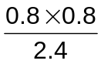

B 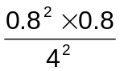

C 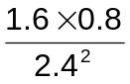

D 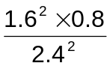

11. What is the final pH of the solution formed by mixing equal volumes of two HCl solutions, one with pH 1.0 and the other with pH 3.0.
A | 1.0 | B | 1.3 | C | 2.0 | D | 2.5

12. A titration was carried out between a weak acid, HA, and aqueous sodium hydroxide. The graph obtained was shown below:

pH

7

volume of NaOH
A suitable indicator for the above titration is
 | Indicator | pH range
A | Thymol blue | 1.5 to 2.5
B | Bromocresol green | 3.8 to 5.5
C | Bromothymol blue | 6.0 to 7.5
D | Thymolphthalein | 9.3 to 10.5

13. Silicon carbide is a major industrial abrasive and a refractory material. Which type of structure explains these properties?
A | A simple covalent structure with covalent bonds between silicon and carbon atoms.
B | A layered structure with covalent bonds between silicon and carbon atoms and weak van der Waals’ forces between the layers.
C | A giant covalent structure with strong covalent bonds between silicon and carbon atoms forming a 3-dimensional network.
D | A giant ionic lattice with strong ionic bonds holding the oppositely charged ions together.

14. The boiling points (b.p.) of ammonia, hydrogen chloride and carbon dioxide are given below.
gas | formula | b.p. / °C
ammonia | NH₃ | −33
hydrogen chloride | HCl | −85
carbon dioxide | CO₂ | −78

Which of the following statements best explains the above data?
A | NH₃ has a higher b.p. than HCl because the hydrogen bonding between NH₃ molecules are stronger than the permanent dipole − permanent dipole interactions between HCl molecules.
B | The strength of the induced dipole – induced dipole interactions increases in the order HCl < CO₂ < NH₃.
C | The strength of the permanent dipole – permanent dipole interactions increases in the order HCl < CO₂ < NH₃.
D | CO₂ has a higher b.p. than HCl because the permanent dipole – permanent dipole interactions between CO₂ molecules are stronger than the permanent dipole − permanent dipole interactions between HCl molecules.

15. The ions P³⁻, S²⁻ and Cl⁻ have radii 0.242 nm, 0.184 nm and 0.181 nm respectively. This decrease in radius in going from P³⁻ to Cl⁻ is due to
A | an increase in the total number of electrons and in the nuclear charge.
B | an increase in the total number of electrons with nuclear charge remaining constant.
C | a constant total number of electrons and an increase in nuclear charge.
D | a constant total number of electrons and nuclear charge.

16. Which of the following elements form an oxide with a giant covalent structure, and a chloride which is readily hydrolysed?
A | Magnesium | C | Phosphorus
B | Sodium | D | Silicon

17. Which of the following oxide is unlikely to dissolve in aqueous sodium hydroxide?
A | MgO | B | Al₂O₃ | C | SiO₂ | D | SO₂

18. How many isomers are possible for the unsaturated compound of molecular formula C₃H₅F?
A | 3 | B | 4 | C | 5 | D | 6

19. Vitamin A plays a role in many functions throughout the human body such as vision, gene transcription, bone metabolism and skin health. The diagram below shows the structure of vitamin A.
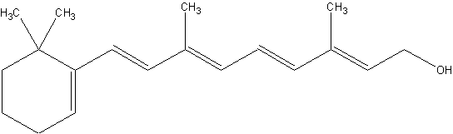
What is the total number of cis-trans isomers of this molecule?
A | 8 | B | 10 | C | 16 | D | 32

20. The table below shows the rate of hydrolysis of the halogen-containing compounds P to S. The rate of hydrolysis is measured by the speed at which the silver halide precipitate is formed.
P | Q | R | S
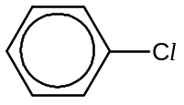 | 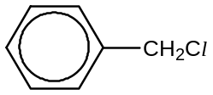 | 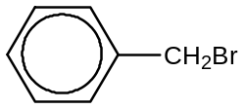 | 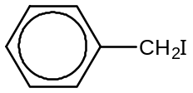
No precipitate formed with prolonged heating with ethanolic AgNO₃. | Precipitate formed after 10 minutes of heating reaction mixture with ethanolic AgNO₃. | Precipitate formed after 2 minutes of warming reaction mixture with ethanolic AgNO₃. | Precipitate forms instantaneously with ethanolic AgNO₃.

Which statement explains the rate of reaction?
A | The C–X bond length increases from compound P to S.
B | The solubility of the compounds increases from P to S.
C | The mechanism for the reaction changes from P to S.
D | The reaction conditions are increasingly milder from P to S.

21. A compound has the following properties:
- It reacts with phosphorus pentachloride, giving off white fumes of HCl.
- It reacts with aqueous bromine.
- It reacts with ethanol
- It reacts with sodium hydroxide to form an ionic compound.
The compound is
A | CH₃CH=CHCOOH
B | CH₃CH=CHCH₂OH
C | CH₃CH=CHCHO
D | CH₃CH₂CH₂COOH

22. Which of the following reagents will distinguish between compounds S and T?
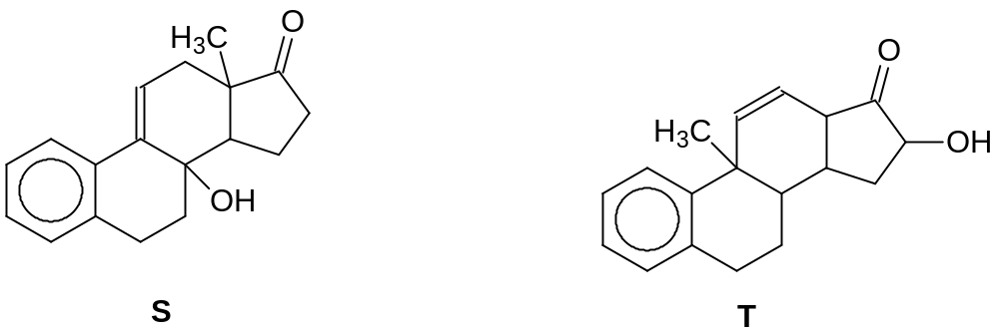
A | Aqueous bromine
B | Alkaline aqueous iodine
C | Acidified potassium dichromate (VI)
D | 2,4 dinitrophenylhydrazine

23. Which observation will NOT be obtained with the compound CH₃CH(OH)CH₃?
A | a pale yellow precipitate when warmed with alkaline aqueous iodine
B | an orange precipitate when warmed with 2,4-dinitrophenylhydrazine
C | fumes of hydrogen chloride gas when heated with phosphorus pentachloride
D | decolourisation of hot, acidified purple potassium manganate(VII)

24. Pentan-2-one is treated with cold hydrogen cyanide in the presence of traces of sodium cyanide. The product X of this reaction is then boiled with hydrochloric acid to give Y. What are X and Y likely to be?
A | 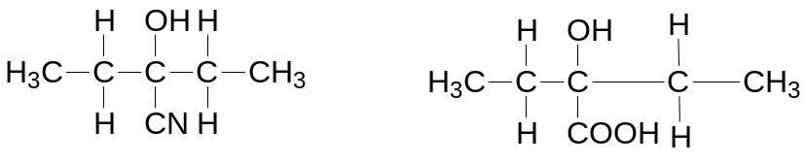
B | 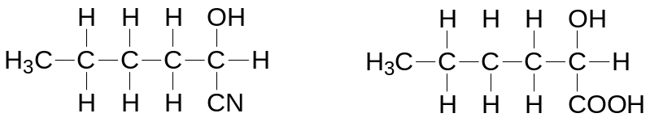
C | 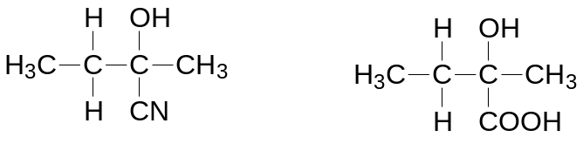
D | 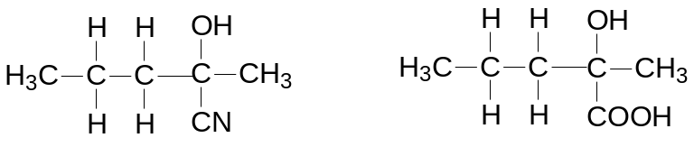

25. Experiments are carried out on three compounds X, Y, and Z.

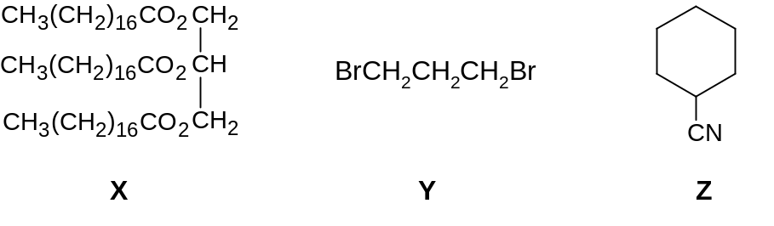

A sample of 0.01 mol of each compound is heated under reflux with 50 cm³ of 1 mol dm⁻³ NaOH (in excess) until hydrolysis is complete and any ammonia produced is expelled from solution.
The excess NaOH is then titrated in each case and is found to require 20cm³, 30 cm³ and 40 cm³ of 1 mol dm⁻³ HCl for neutralisation.

Which sequence of compounds matches these results?

 | 20 cm³ | 30 cm³ | 40 cm³
A | X | Y | Z
B | X | Z | Y
C | Y | Z | X
D | Z | Y | X

Section B
For each of the questions in this section one or more of the three numbered statements 1 to 3 may be correct.
Decide whether each of the statements is or not correct (you may find it helpful to put a tick against the statements which you consider to be correct).
The responses A to D should be selected on the basis of
A | B | C | D
1,2 and 3 are correct | 1 and 2 only are correct | 2 and 3 only are correct | 1 only is correct
No other combination of statements is used as a correct response.

26. The energy profile diagram for the reaction P + Q → R is shown below:
Energy
Reaction coordinate
P + Q
R
ΔE₁
ΔE₂
1 The activation energy of the forward reaction is ΔE₂ + ΔE₁
2 The activation energy of the reverse reaction is ΔE₁
3 The enthalpy change of the reverse reaction is ΔE₂

27. In which sequence(s) are the molecules quoted in order of increasing bond angle within the molecule?
1 |  | H₂O NH₃ CH₄
2 |  | H₂O SF₆ BF₃
3 |  | CH₄ CO₂ SF₆
 | A |  | B | C | D
 | 1,2 and 3 are correct |  | 1 and 2 only are correct | 2 and 3 only are correct | 1 only is correct

28. Why is a solution of aluminium chloride acidic?
1 | Chloride ions react with water to form hydrochloric acid.
2 | Aluminium ions have a high charge density.
3 | The H-O bonds are weaker in [Al(H₂O)₆]³⁺ than in H₂O.

29. What deductions can be made about the psychoactive drug, W, in cannabis as shown in the structure below?
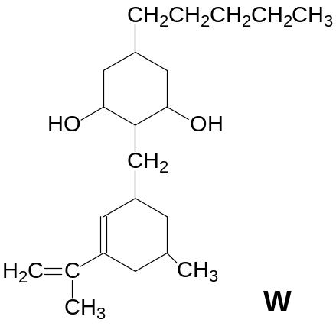

1 | W reacts with concentrated sulphuric acid at 180°C to form a product that decolourises aqueous bromine at room temperature.
2 | W can form cis-trans isomers
3 | W reacts with sodium metal to form 2 moles of hydrogen gas.

A | B | C | D
1,2 and 3 are correct | 1 and 2 only are correct | 2 and 3 only are correct | 1 only is correct

30. Which of the following statements about benzene are correct?
1 | The carbon atoms form a regular planar hexagon.
2 | Addition reactions of benzene take place more easily than substitution.
3 | Each carbon-carbon bond in benzene is stronger than a carbon-carbon double bond in ethene.

---End of Paper---

